Jagadambha College of Engineering & Technology, Yavatmal
Department of Computer Engineering
University Merit- 2024

Sr. No. | Name of Student | CGPA | Merit No. | Photo
1 | Tejas Ramrao Pillare | 9.07 | 1 | 
2 | Triveni Subhash Rathod | 9.00 | 2 | 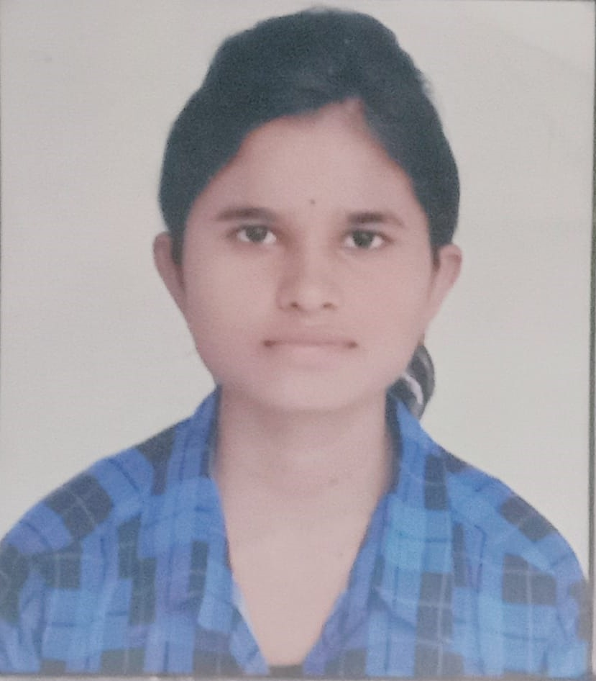
3 | Yashashri Chandrashekhar Gayki | 9.00 | 2 | 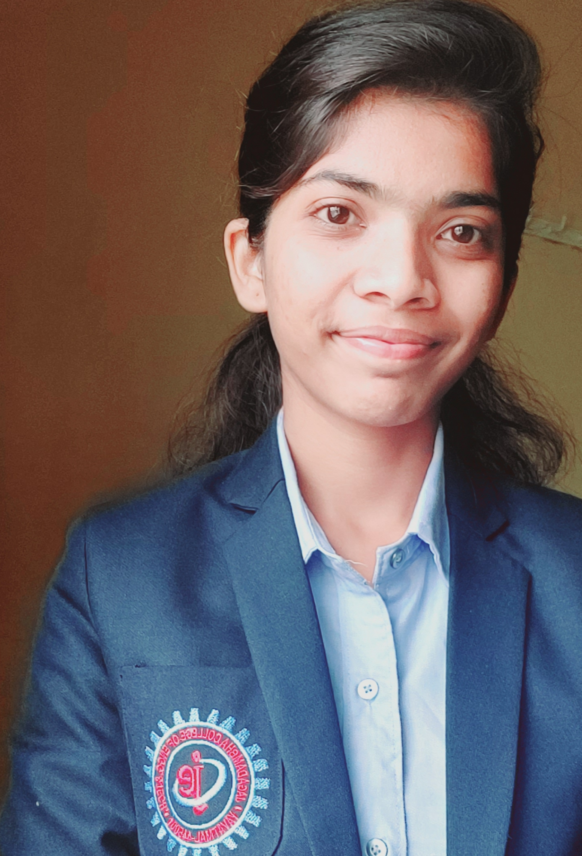
4 | Sanika Vivek Pande | 8.86 | 3 | 